New Campaign Page Brief: Dean Chamberlain – Customer Story
URL: https://www.caseih.com/anz/en-nz/News/Pages/News_Stories/The-business-supporting-over-a-hundred-Cantebury-farmers.aspx
Page brief: Please also include the hero image as the thumbnail for the news piece on the following page: https://www.caseih.com/anz/en-nz/about-case-ih/news-centre
Go live timing: 22/10/2021
Content to include:
{HERO IMAGE}
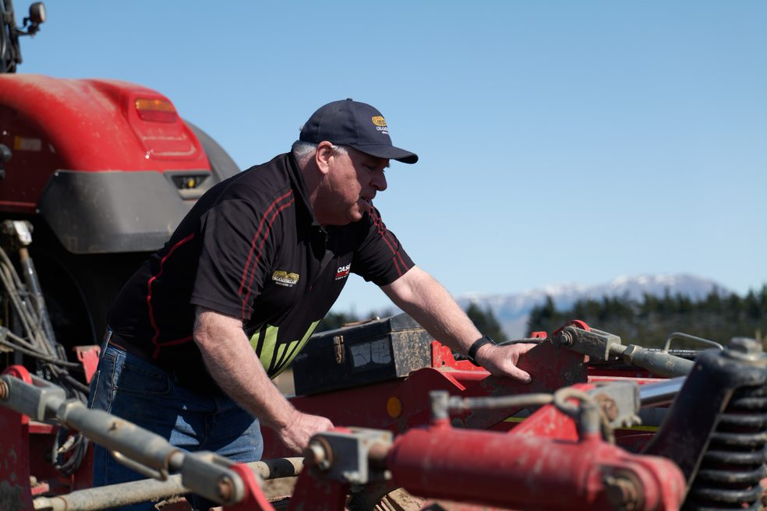
Headline Text
The business support over a hundred Canterbury farmers
Body Text
In stunning rural Canterbury, 50 kms west of Christchurch near Sheffield, Dean Chamberlain and his wife Jackie are preparing for a busy season supporting around 150 local farms.
Family owned and operated Chamberlain Agriculture Limited specialises in producing baleage and fine chop silage. They provide a full service – mow, rake, bale, cart, wrap for baleage; chop, cart, stack or bag silage; bale straw and hay.
“You could say we’re a one-stop-shop for local farmers,” says Dean.
“October to March we’re busy from sun up to sun down, travelling to farms up to 50 kms away with all our equipment. We mainly process feed for stock, but we do a raft of other things that help keep a farm ticking along and running smoothly.”
For many farmers, contracting out to businesses like Chamberlain Agriculture is the way to go. The cost of purchasing and maintaining the wide range of equipment needed to run a farm can be significant, and harvesting machinery requires experienced operators. Hiring skilled workers like Dean and his crew mean large areas can be processed in a short amount of time, which is important to maintain the quality of the feed - and wellbeing of stock.
Born and raised in rural Canterbury on a mixed sheep, cattle and crop farm, Dean understands what it takes to keep complex farming operations moving. He says he never thought about doing anything else.
“We’re rural people, so I always wanted to work in the industry supporting the rural community,” Dean says.
“I get to meet lots of people and deal with the farmers who work hard every day to help feed and support other kiwis. It’s very rewarding.”
Like many Kiwi businesses, Chamberlain Agriculture has faced challenges due to the ongoing Covid-19 pandemic. Many of Dean’s skilled employees come from overseas, and he is having to work with a reduced number of staff. But in true Kiwi fashion, Dean says “you just get on with it.”
“Farmers need to feed their stock, clear their fields and plant new crops. They can’t stop, so we can’t either. They rely on us, and I take that responsibility very seriously.”
Dean has also seen the industry evolve in many ways over the years. He says technology has changed particularly fast, with machinery no longer purely functional, but also focused on health and safety and operator comfort. For a business that revolves around the reliability of its equipment, he’s very selective when it comes to what he invests in.
“I’ve been in the business for 16 years, and I’ve been buying the same brand for 15 of those years,” he says.
“We run eight Case IH tractors and four Case IH balers which we got from our local Leeston dealer. All our equipment does the hard yards, but the quality of the Case IH machinery stands out for us. I’ve never considered using anything else to be honest.”
“If there are any issues, the team is on the other end of phone any time, any day of the week to sort it out and keep me moving.”
When asked about what the future holds, Dean doesn’t look too far afield.
“We’re just continuing to do what we do, providing the best possible service and focusing on the quality of our work.”
“We’ve already started getting a few early jobs in for the season that are keeping us busy, and we’re happy to be out there helping our clients.”
Subheading
About Case IH
Body Text
With over 175 years in the field, Case IH is a global leader in agriculture and farm equipment, bringing our customers innovative products and market leading agricultural solutions and services. We take on challenges for you. We make life easier for you. We provide you with peace of mind. That’s what we do. We’re Case IH.
Image Gallery/Carousel
Could we please also include the following images as a carousel style gallery:
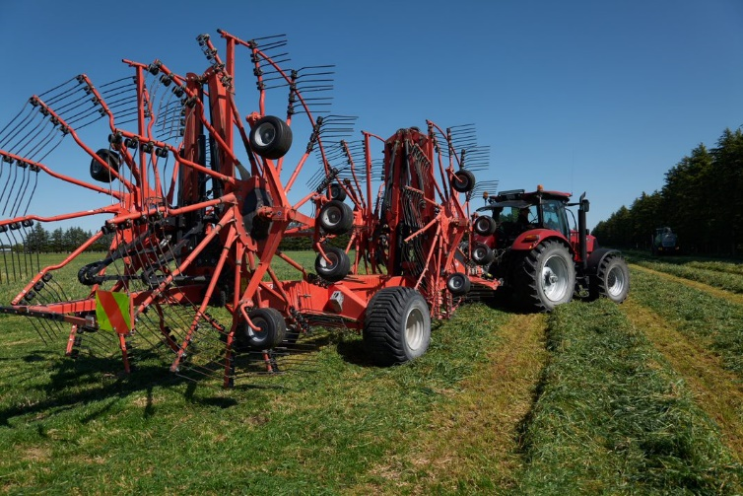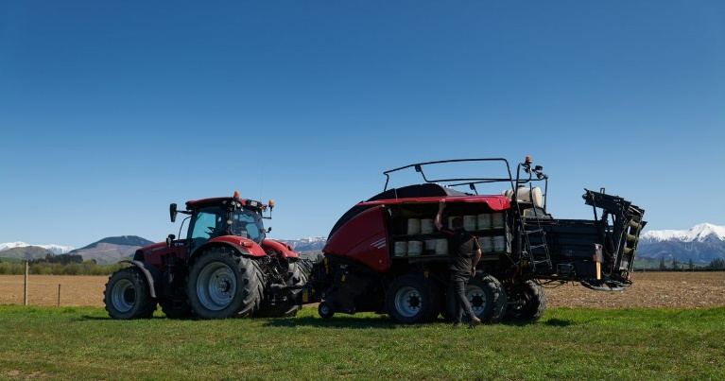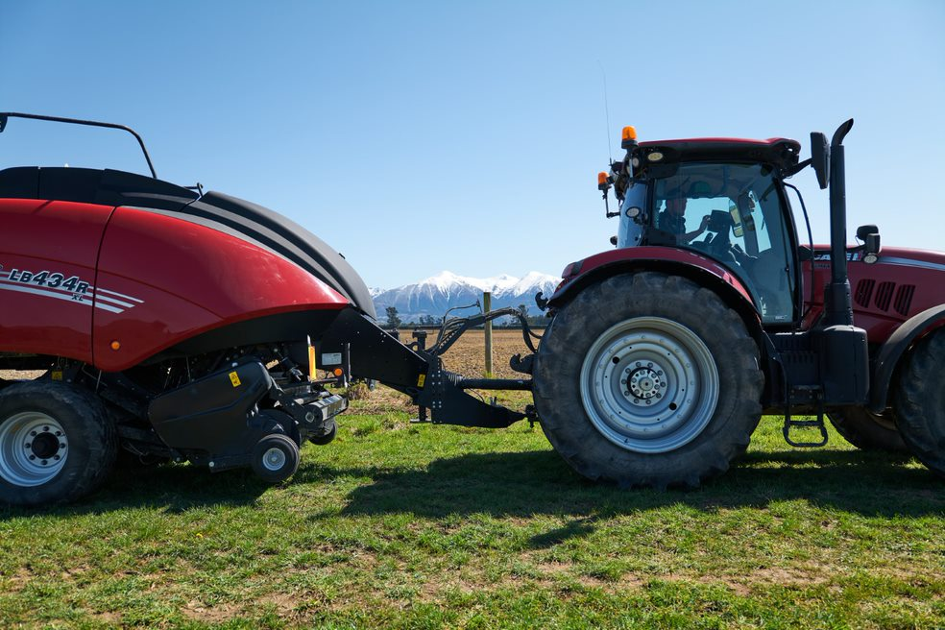

I will also include these as attachments on the request form

Resources
Could we please do something similar to the below, with the corresponding hero image and attached word doc version of the news piece included?

Is there a way to get each of these three resources evenly proportioned please?

